SQL Analysis – Tennis Data (SportRadar API)
- Objective
The objective of the SQL part was to store the extracted API data into a relational database, perform data cleaning, and generate analytical insights using SQL queries.
- Database & Tables Created
Database: tennis_analytics
Tables created:
- categories
- competitions
- complexes
- venues
- competitors
- rankings
All tables were created using PostgreSQL and populated using CSV files generated from API extraction.
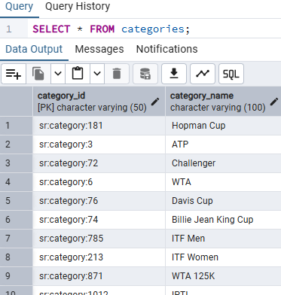

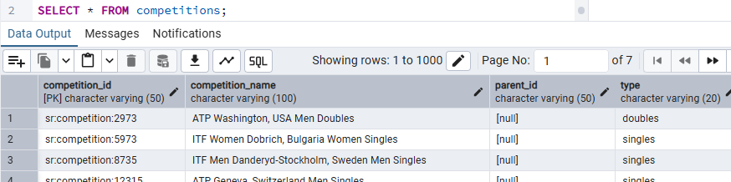
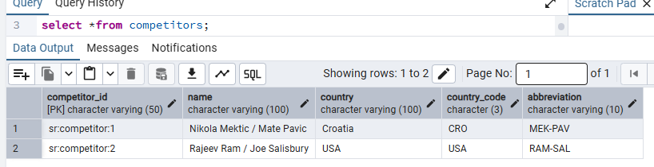
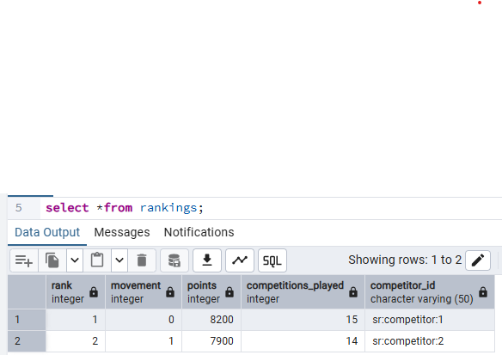

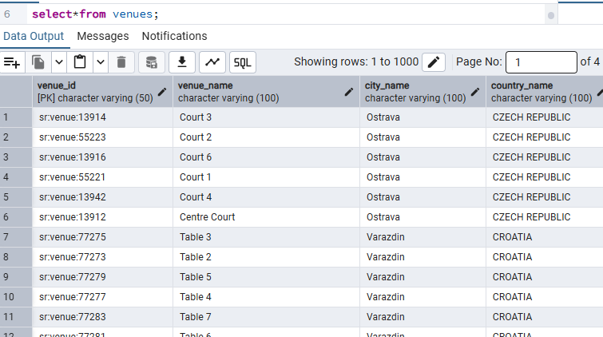
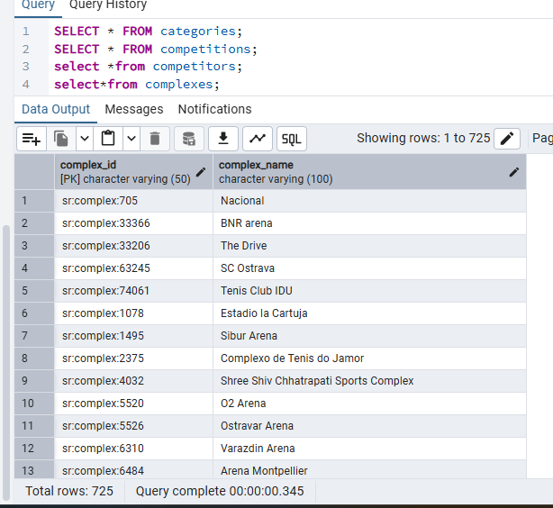
- Data Cleaning Performed
- Checked for null values and duplicates
- Verified data types for numeric and text columns
- Ensured correct foreign key relationships
- Fixed column-mapping issues during rankings import
- Recreated rankings table to resolve import errors
- KPI Summary
QUERY: -SELECT
COUNT(*) AS total_players,
AVG(points) AS avg_points,
MAX(points) AS max_points,
MIN(rank) AS best_rank
FROM rankings;
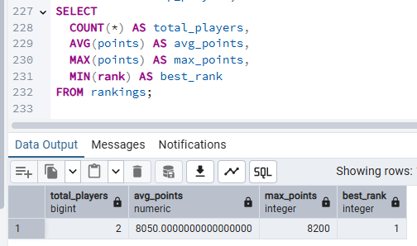
Insight: Provides an overall performance summary of ranked players.
Top Players Analysis:
QUERY: - SELECT c.name, r.rank, r.points
FROM rankings r
JOIN competitors c ON r.competitor_id = c.competitor_id
WHERE r.rank <= 10;
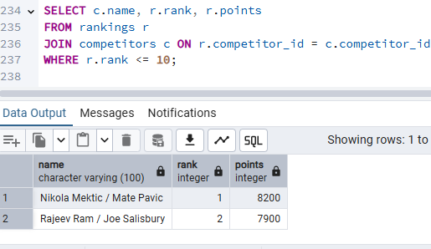
Insight: Identifies top-performing players based on rankings and points.
Ranking Distribution Analysis
QUERY: - SELECT CASE
WHEN rank BETWEEN 1 AND 10 THEN 'Top 10'
WHEN rank BETWEEN 11 AND 50 THEN 'Top 11–50'
WHEN rank BETWEEN 51 AND 100 THEN 'Top 51–100'
ELSE 'Above 100'
END AS rank_group,
COUNT(*) AS player_count
FROM rankings
WHERE rank IS NOT NULL
GROUP BY rank_group
ORDER BY player_count DESC;
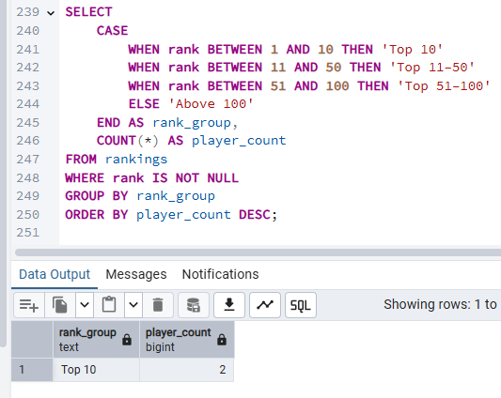
Insight: Used to understand how players are distributed across ranking tiers.
Views for Reusability
QUERY: -CREATE VIEW top_players AS
SELECT
c.name AS player_name,
r.rank,
r.points
FROM rankings r
JOIN competitors c
ON r.competitor_id = c.competitor_id
WHERE r.rank <= 10;
SELECT * FROM top_players;
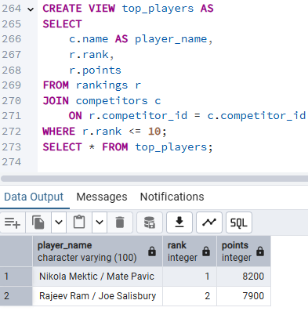
A SQL view (top_players) was created to allow reusable and dynamic access to top-ranked player data.
Venue Distribution by Complex
→ Infrastructure & tournament capacity
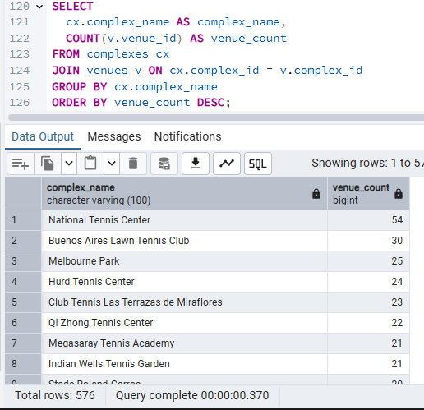
Insights: Identification of Major Tennis Hubs.
Country-wise Player Distribution
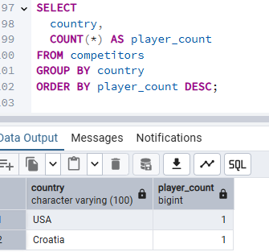
Performance-Based Player Ranking.
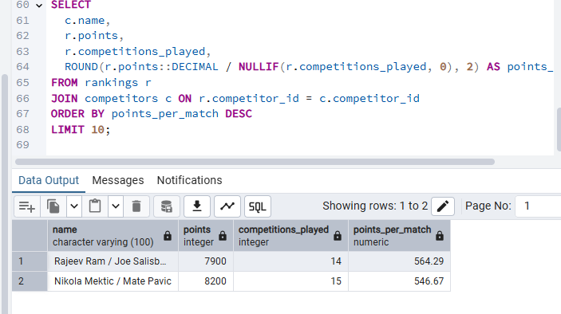
This analysis identifies players who earn the highest points per match, highlighting efficiency rather than total matches played.
Player Performance Efficiency
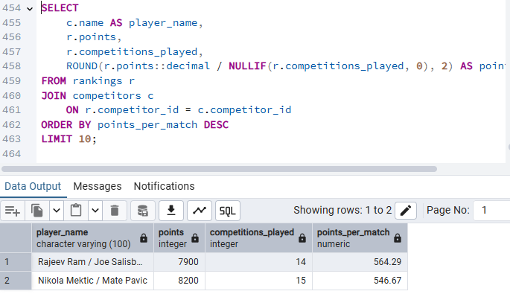
Insight: This highlights players who are highly efficient, earning more points per match played.
Conclusion
The SQL component successfully handled data storage, cleaning, validation, and analysis. The generated insights support further visualization and reporting tasks.

